**Creating an executable jar file (for GUI’s only) thru Eclipse**

**Step 1. Create Launch Configuration**

Choose a java file in your project that has a main() method to be intially launched when your jar file is clicked on.

Right on the chosen java file and choose **Run As**>**Run Configurations...**

Go to your **Java Application** tree (expand it if necessary) and click once on your desired app name you wish to create an executable jar for. You should now see a new configuration is set for you to name! You are now ready to set up the Launch configuration.

Add in a desired Name for your Launch configuration where it says **Name**.

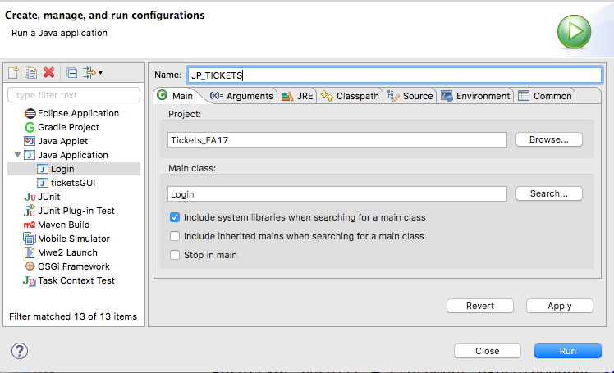

Leave all other defaults intact and check though the option to **Include system libraries when searching for a main class**.

Click Apply then Run.

Note, your Launch Configuration **name** has now been added as a configuration option located in your Java Application tree.

Close out of your pop up window of your now running app when you see it.

**Step 2. Export Runnable Jar file**

Now right click on your **project** in Eclipse and choose Export.

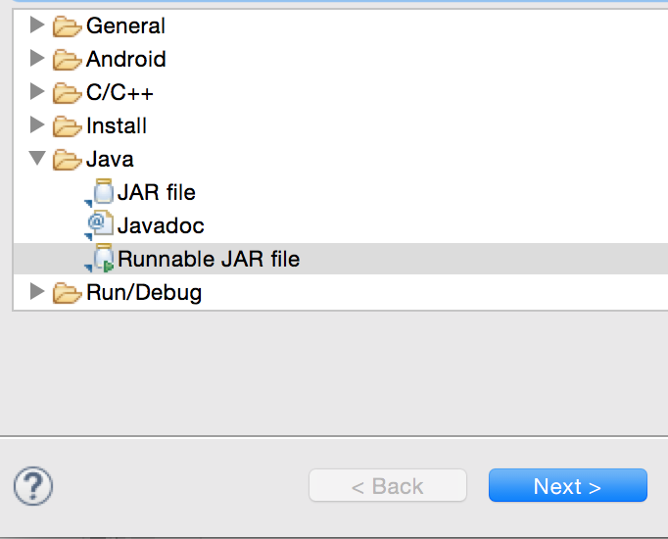

Drill down the Java folder and select Runnable JAR file. Select Next>.

Select your Launch configuration name from the pull down menu in the Runnable Jar File Specification dialog box with the launch confguration you *just* created.

Then select the path or Export destination for your desired jar. Name your export jar file appropriately. Include your **first initial + first four letters of your last name + _tickets_app** as your jar file name.

Keep all defaults, but make sure the option **Extract required libraries into generated JAR** is selected and press Finish.

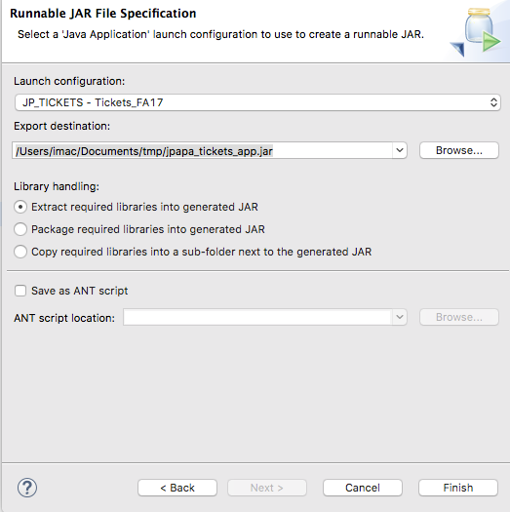

Press OK for any pop up dialog messages such as warnings or error messages to complete your mission.

Go to your jar file you just created within your desired path and run it. It should work. If not go back to the prior steps and check what went wrong. It could be trouble too if someone does not have the JRE installed on a given machine.